**LAB MANUAL**

**Week – 1 | ARTIFICIAL INTELLEGENCE**

**Lab - 13**



**Working with Prompts**

**Use prompts for different actions**

**Objective:**

The objective of this lab is to work with difflent types of prompts as:

1. Text Generation Prompts
2. Image Generation Prompts
3. Code Generation Prompts ()
4. Business and Marketing Prompts
5. Miscellaneous Prompts

**Equipment Required:**

1. Computer with internet access
2. Web Browser
3. Jupyter
4. Python

**Prerequisites:**

* Basic understanding of GenAI
* Prompts in GenAI

**Problem Statement:**

Use of difflent types of prompts to retrieve the information

* Text Generation Prompts
* Image Generation Prompts
* Code Generation Prompts ()
* Business and Marketing Prompts
* Miscellaneous Prompts

**Procedure:**

**Objective 1:** Understand text generation using AI models.

**Tasks:**

* Generate short paragraphs of text on given topics.
* Create dialogue between two characters.
* Write a product description.
* Generate a short story based on a given plot outline. **(DIY)**

**Tools/Resources:**

* + OpenAI GPT models (e.g., GPT-3, GPT-4)
  + Python or API interfaces for model interaction

**Steps:**

Step1: Goto OpenAI/ Co-pilot or any other text generation platform,   
<https://chatgpt.com/>

<https://copilot.microsoft.com/>

Step 2: Register if required

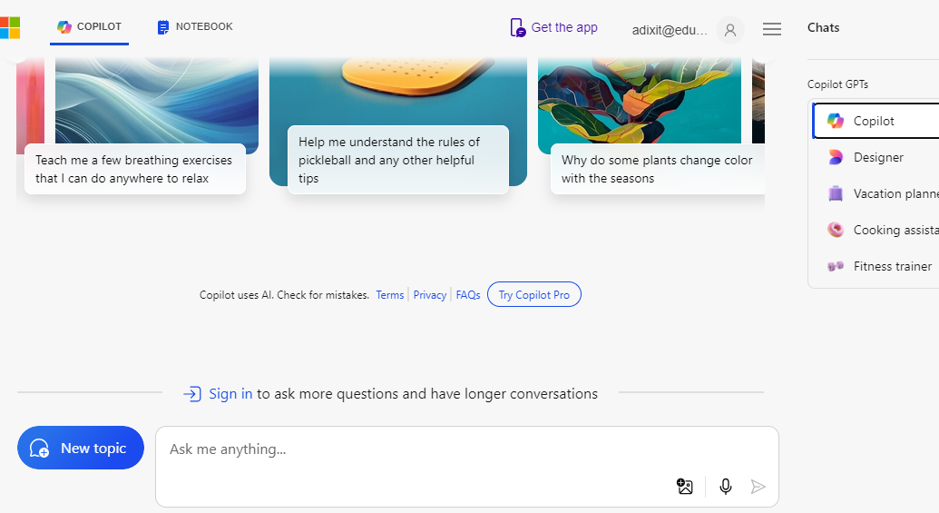

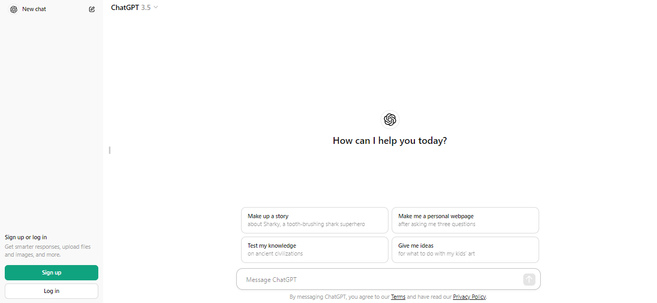

Step: 2: Input some text in text box as “write a paragraph on world yoga day”

See the output:

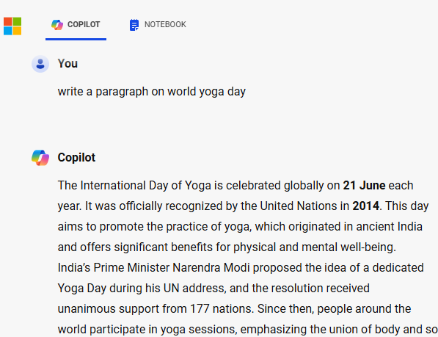

Step 4: Now “Create dialogue between two characters named Harry and John Wick”



Step 5: Write a product description- honey bottle.

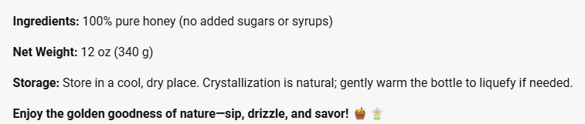

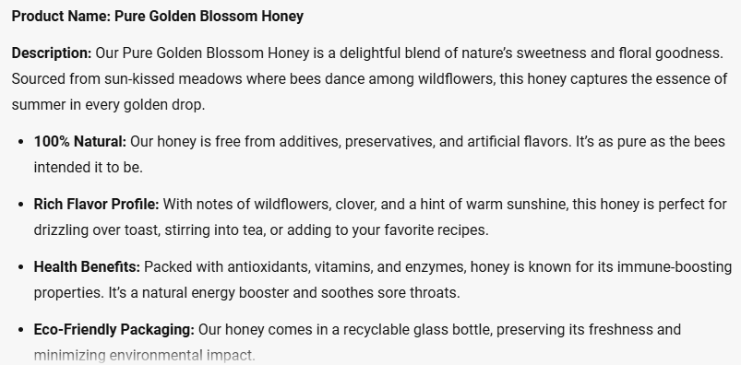

**Objective 2:** Generate images using AI models.

1. **Tasks:**

* Generate images of bees with honey.
* Create stylized artwork of filling honey in bottle in forest as background.
* Design a stocks of honey bottles. **(DIY)**

1. **Tools/Resources:**

* DALL-E for image generation
* Use of neural network-based tools for artistic rendering

Step 1:

Goto Co-pilot:

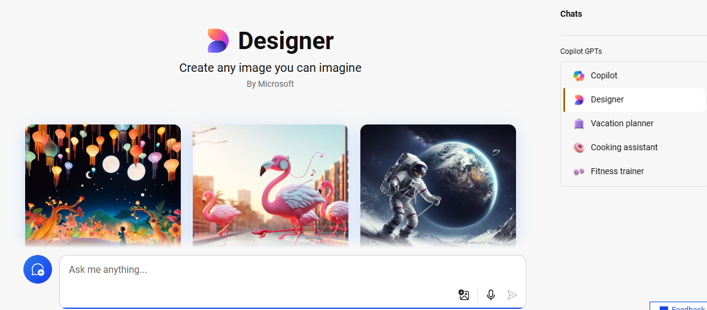

Step2:

* Write your imagination into prompt: Generate images of bees with honey.

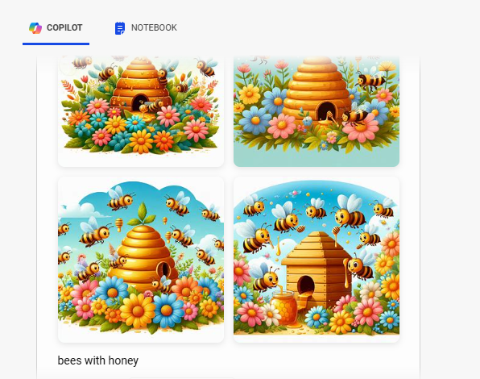

* Step 3: Create stylized artwork of filling honey in bottle in forest as background.

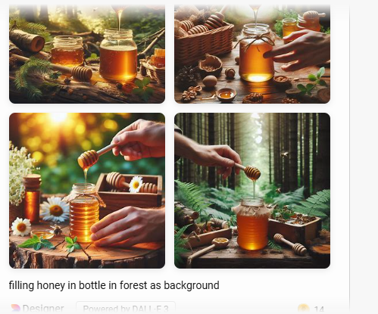

**Objective 3:** Automate code creation using AI models.

1. **Tasks:**
   * Create functions or algorithms that create a user with name, email, and job-profile.
   * Auto-complete code based on partial inputs.
   * Generate snippets of code for python program that calculate sum of input numbers. **(DIY)**
2. **Tools/Resources:**
   * GitHub Copilot or similar AI-driven IDE plugins
   * Programming language-specific APIs for code generation

Step 1: goto <https://ollama.com/> download and install it

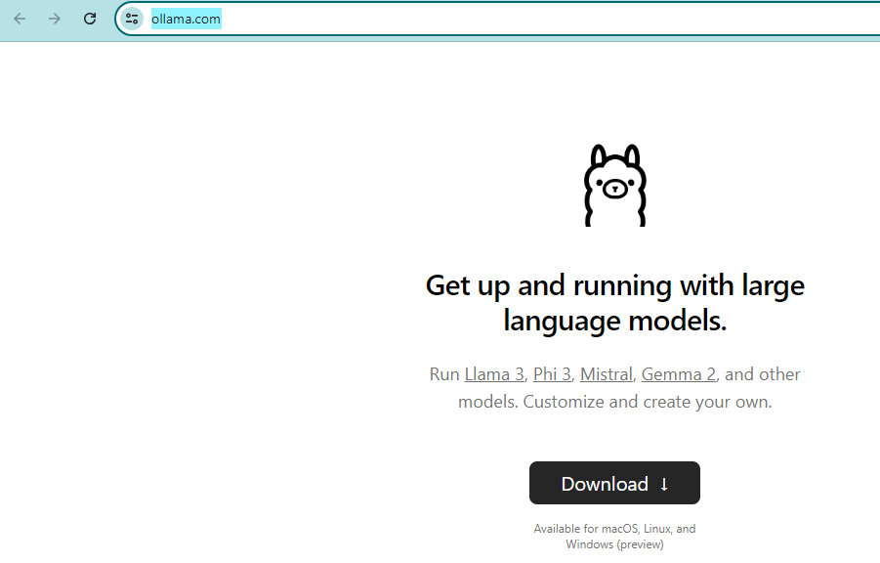

Step 2: Open VS Code and install Llama coder plugin

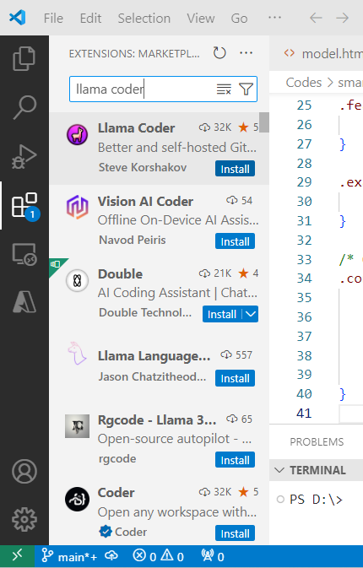

Step 2: In first time it will ask you to download model

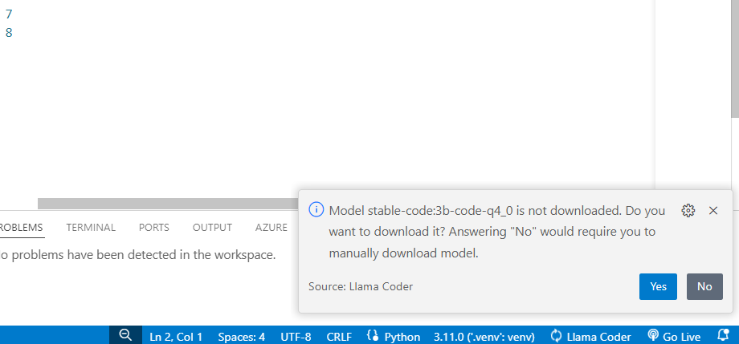

After this it will look like



Step 4:

**Objective 4:** Use AI for business and marketing applications.

1. **Tasks:**
   * Write promotional content for a new product launch (Himalayan honey).
   * Generate meeting link automatically
   * Create market research reports based on industry data.
2. **Tools/Resources:**
   * AI tools specialized in marketing copywriting
   * Data analytics platforms for market research

Step1: input “Write promotional content for a new product launch (Himalayan honey)” in prompt.

🌿 **Introducing Himalayan Honey: Pure Nectar from the Rooftop of the World!**

Are you ready to experience the golden essence of the Himalayas? Look no further! Our premium Himalayan Honey is a symphony of nature’s finest flavors, crafted by bees that dance amidst pristine alpine meadows.

**Why Choose Himalayan Honey?**

1. **Unspoiled Ecosystem**: Our hives are nestled in the heart of the Himalayan range, where lush forests, crystal-clear streams, and rare flora thrive. The bees feast on wildflowers, creating a honey that’s as pure as the mountain air.
2. **Rich in Nutrients**: Himalayan Honey is packed with antioxidants, vitamins, and minerals. It’s nature’s elixir for your well-being.
3. **Delicate Floral Notes**: Close your eyes and taste the sun-kissed blossoms—jasmine, rhododendron, and wild lavender—all captured in every spoonful.
4. **Sustainably Harvested**: We respect our buzzing partners. Our beekeepers follow ethical practices, ensuring the bees flourish while we collect their liquid gold.

**How to Enjoy Himalayan Honey?**

* Drizzle it over warm toast or fresh yogurt.
* Sweeten your herbal teas or morning coffee.
* Boost your immunity with a spoonful daily.

**Limited Batch**: Our first harvest is a celebration of nature’s bounty. Don’t miss out!

🍯 **Unlock the Himalayan Secret**: Visit our website or your nearest store to savor this rare treasure. 🏔️

Step 1 Register <https://otter.ai/> for creating auto meeting notes

Step 2 add people in workspace:

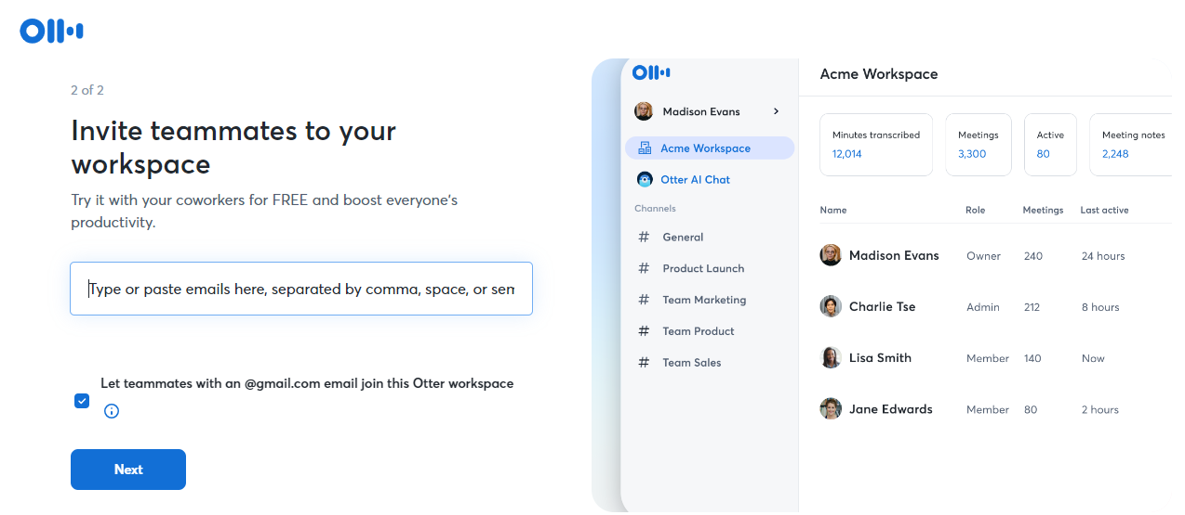

Step 3: Set meeting

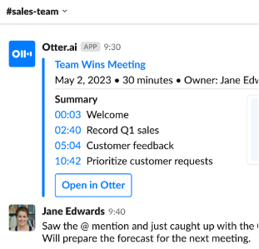

**Objective 5:** Explore other applications of AI-generated content. **Tasks:**

* + Create a poster for honey marketing with company name Golden Honey.
  + Generate poetry. **(DIY)**

**Tools/Resources:**

* + Custom prompts using general-purpose AI models
  + Niche-specific AI tools for creative writing and technical documentation

**Step:**

**Use and signup at canva**

**Choose ai creation put “create a poster for honey marketing: company name golden honey” in prompt**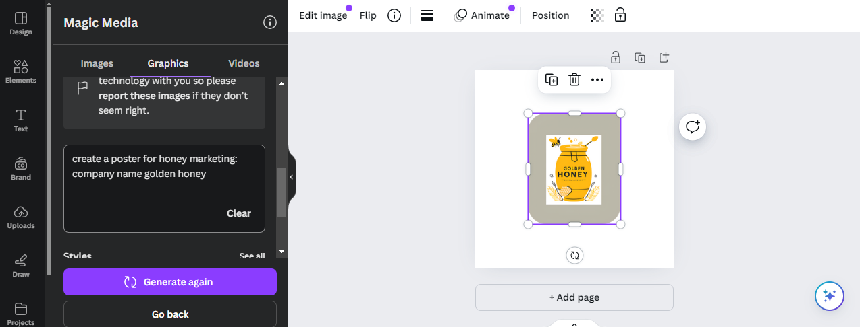

**Conclusion:**

In this example, learnings from working with different prompts has been done to generate new information.